*Git Notes

git init – create a new repository

new hidden folder - .git

Git Object Types

1) Blob – any files

2) Tree - folders/directories

3) Commit – store different versions

4) Annotated Tag – persistent text pointer to specific commit

git hash-object

git cat-file

Blob
$ echo “Hello Git” | git hash-object --stdin

Git database consists of key-value pairs similar to JSON objects.

Hash is generated based on the contents of the file.

Hash functions are one-way functions

Same hash function will always create same hash for same input.

MD5 – 128 bits
SHA1 – 160 bits
SHA256 – 256 bits
SHA384 – 384 bits
SHA512 – 512 bits

Git uses SHA1 Hash function

How many files could git store in a repo? - 2^160.

What is the probability of hash collision? - 1/(2^320).

$ git cat-file -p <hash> - contents of the object

$ git cat-file -s <hash> - size of the object

$ git cat-file -t <hash> - type of the object

$ git hash-object <filename> -w

Git repository stores files independently in its own file system in the objects directory

Git blobs don’t have filenames. Hash values doesn’st use filenames.

Size and type are stored in blob.

Contents of Git Objects

Object type + Object Length + Delimiter + Content = Hash

Git stores files in compressed binary format

Tree

Trees store filenames/directory names.

Contents
Filetype+Permissions – type – SHA1 hash – filename

040000 – Directory
100644 – regular non-executable file

$ git mktree

From Git repository to Staging Area:
$ git read-tree <hash>

From Staging Area to Working Directory:
$ git checkout-index -a

Git Basic Operations

Every commit consists:
Author name and email
Commit description
parent

Commit is a wrapper around Tree object in Git database.

Configuing email and author:
$ git config –global user.name <Name>
$ git config –global user.email <mail-id>

$ git config –list

To commit:
$ git commit -m “<Message>”

Basic Git commands:
$ git status

$ git add

$ git commit

$ git log

$ git checkout

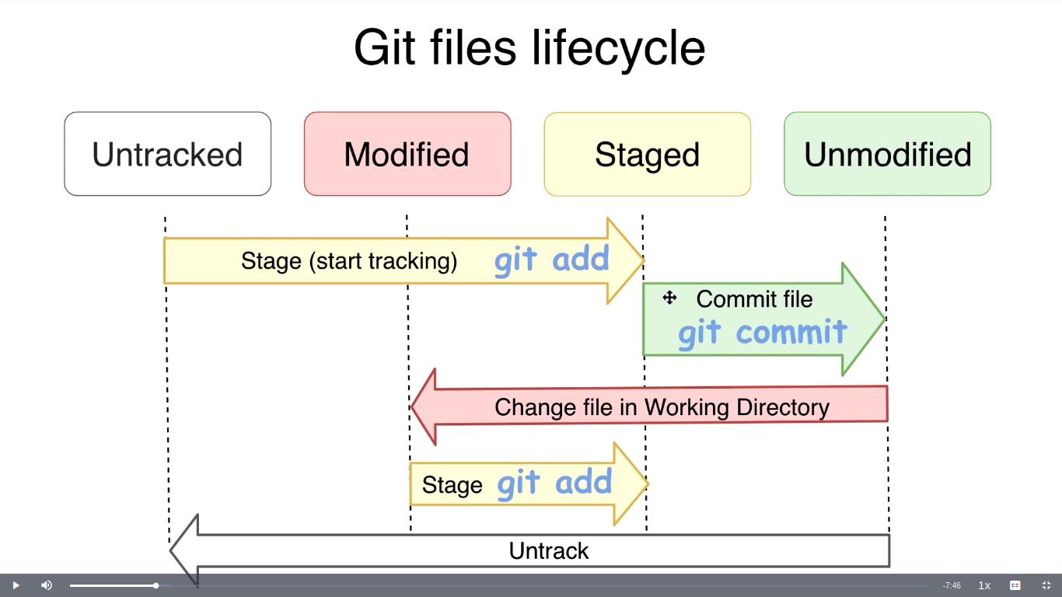
$ git ls-files -s

$ git rm –cached <filename>
To remove from staging area (Undo git add)

BRANCHES

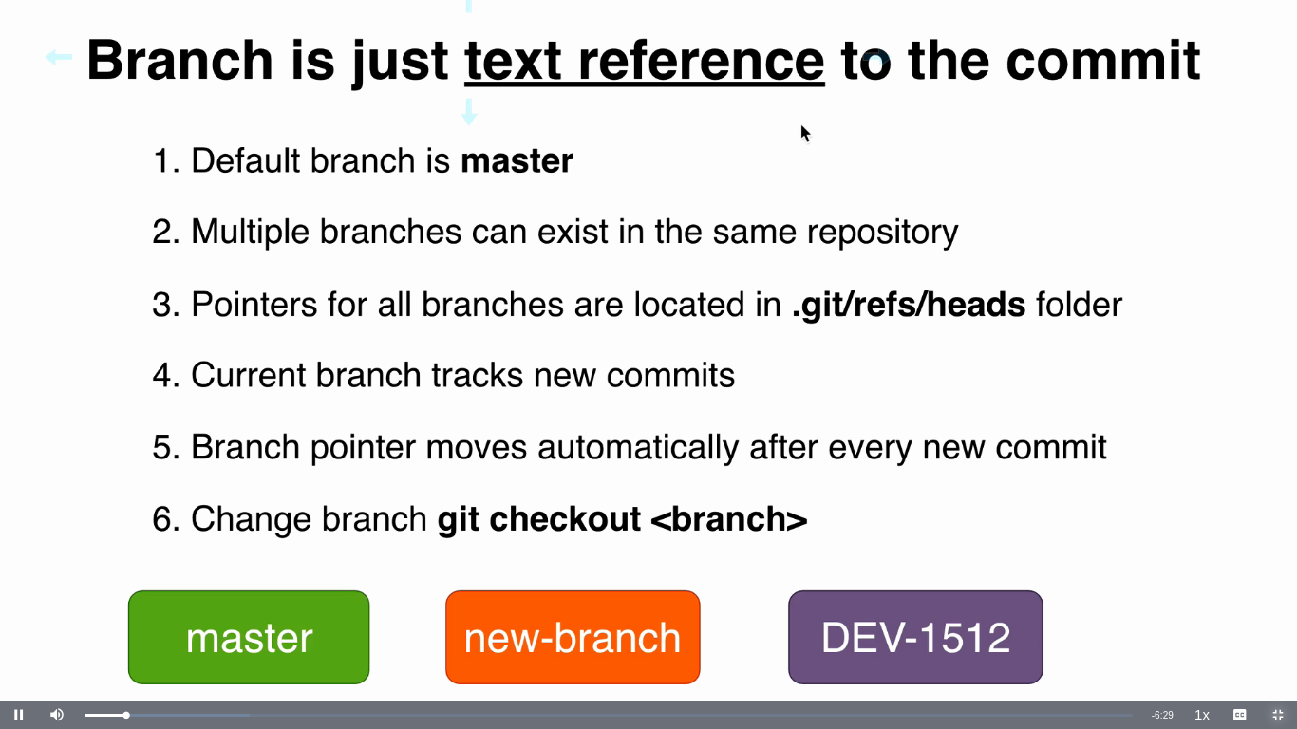

HEAD

HEAD is pointer to specific branch/commit

There could be multiple branches and multiple commits in each branch but only one HEAD.

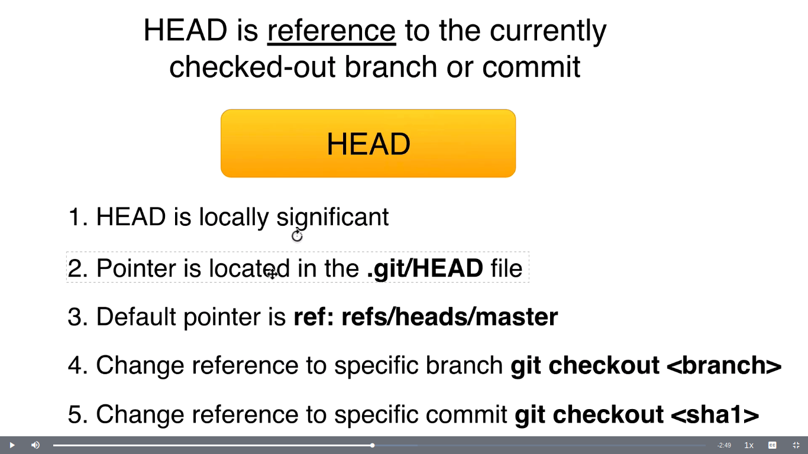

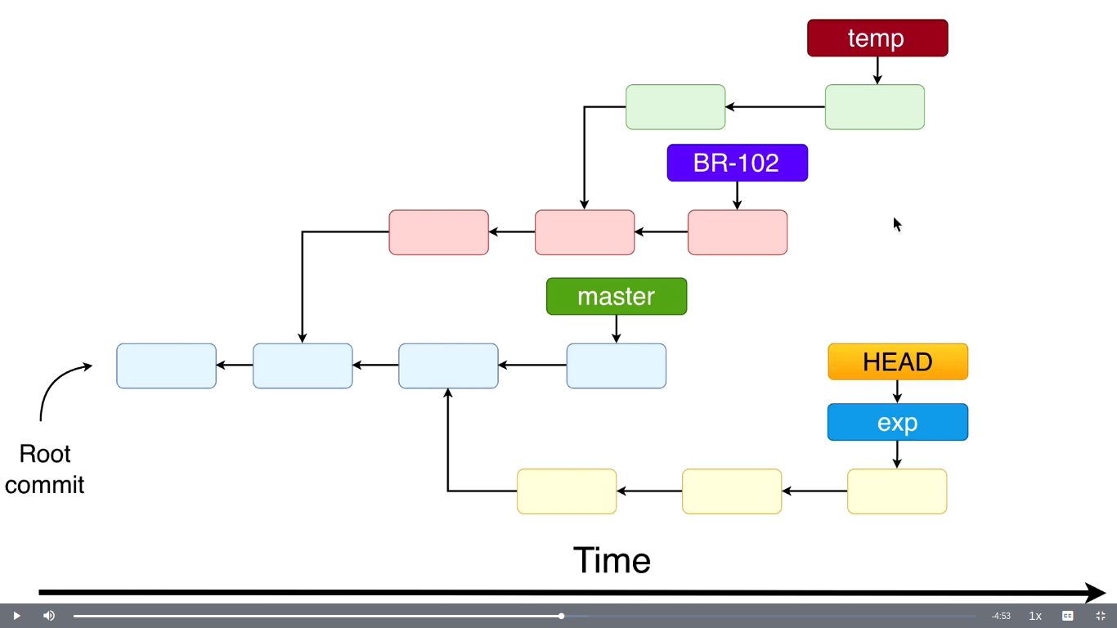
Every branch represents separate history (parallel development) of your repository.
Greatly simplify collaboration projects.
Easier to checkout using branch names.

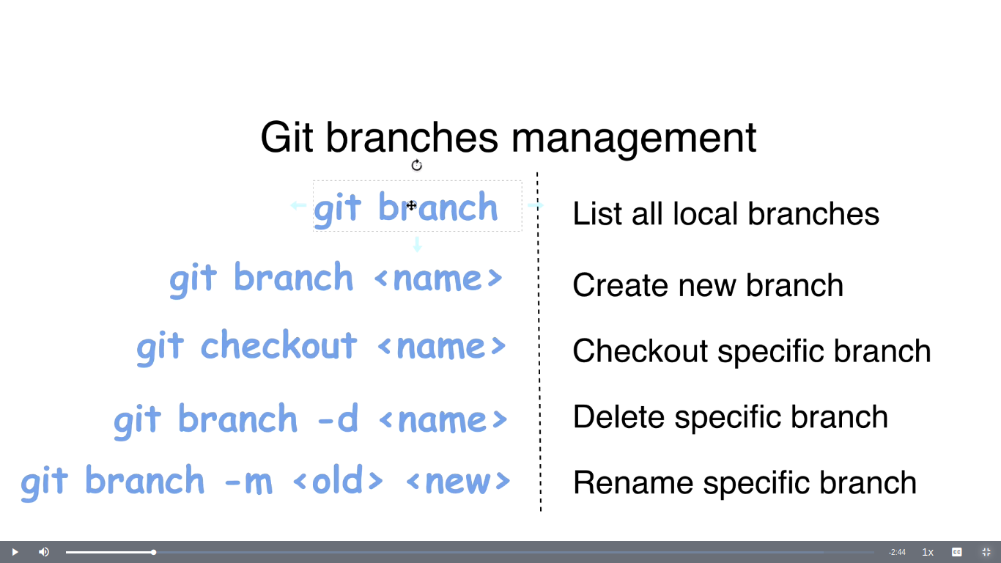

$ git checkout -b <branch name>
Create a branch and checkout

To unpack a cloned repository,

$ cat pack-xxxx.pack | git unpack-objects

To view the changes in files,
$ git diff

-also shows provisional SHA1 hash

Merging branches

Fast forward merge

$ git merge <feature-branch>

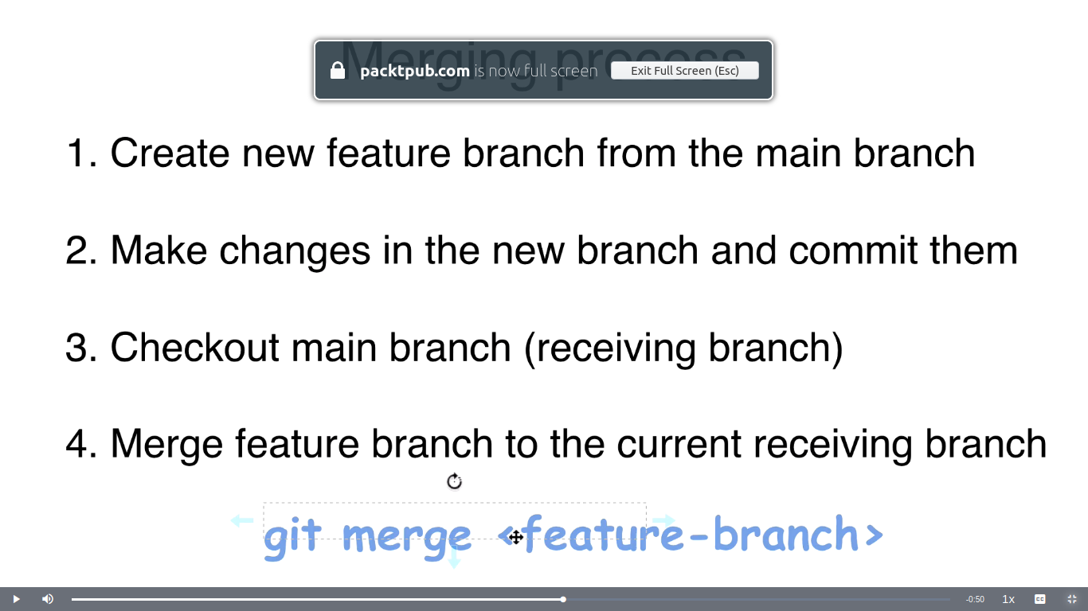

3-way merge

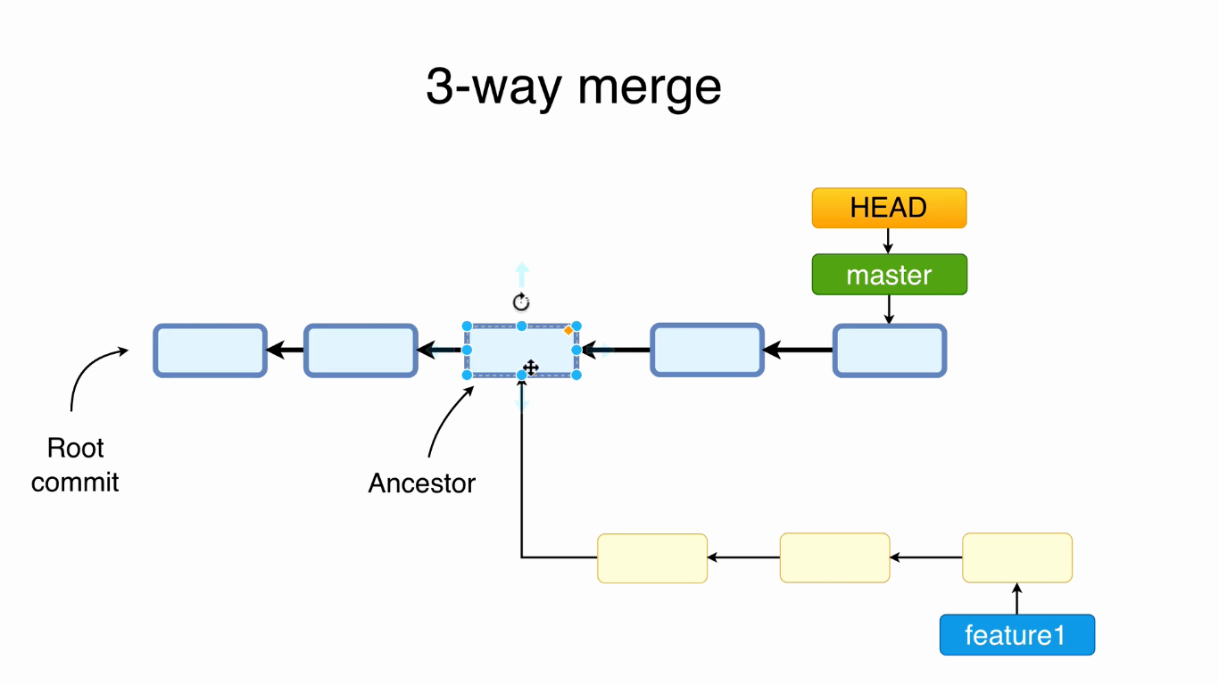
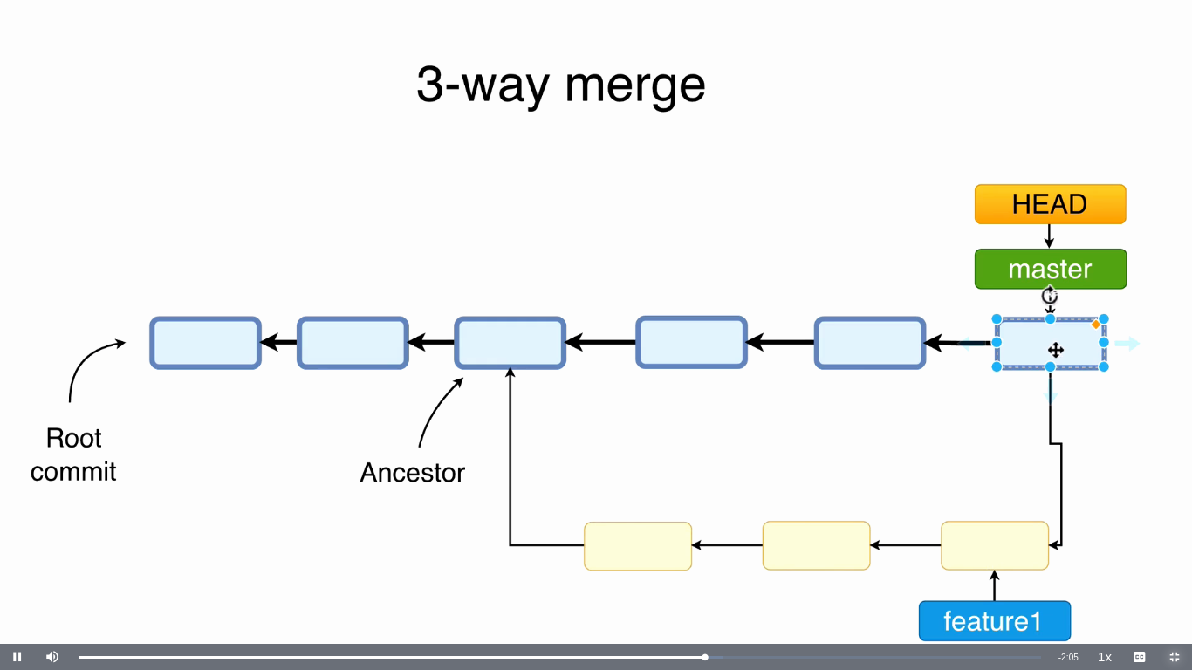

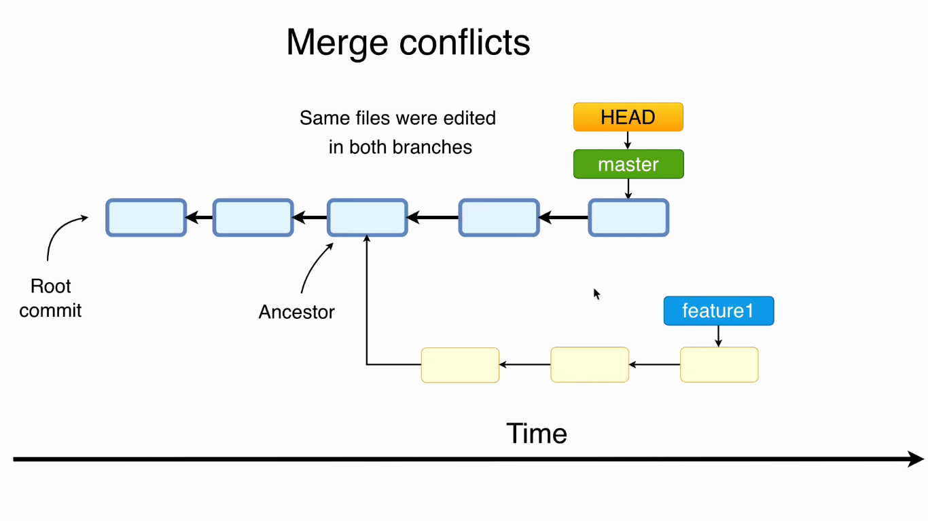

Cloning

$ git clone <link>

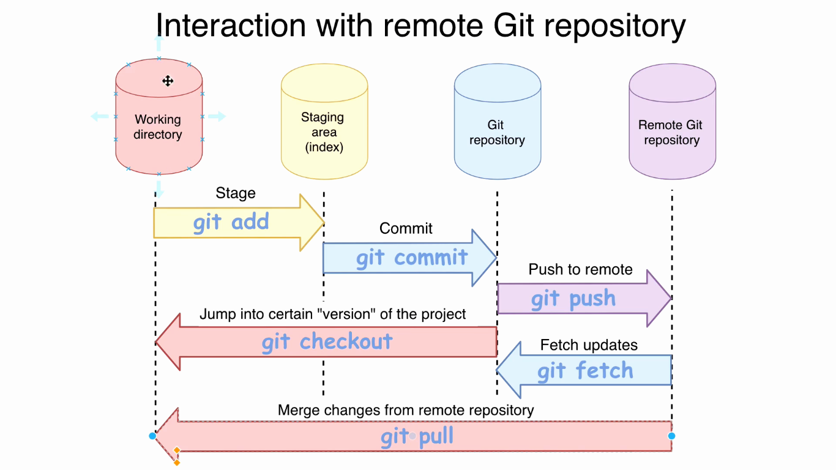

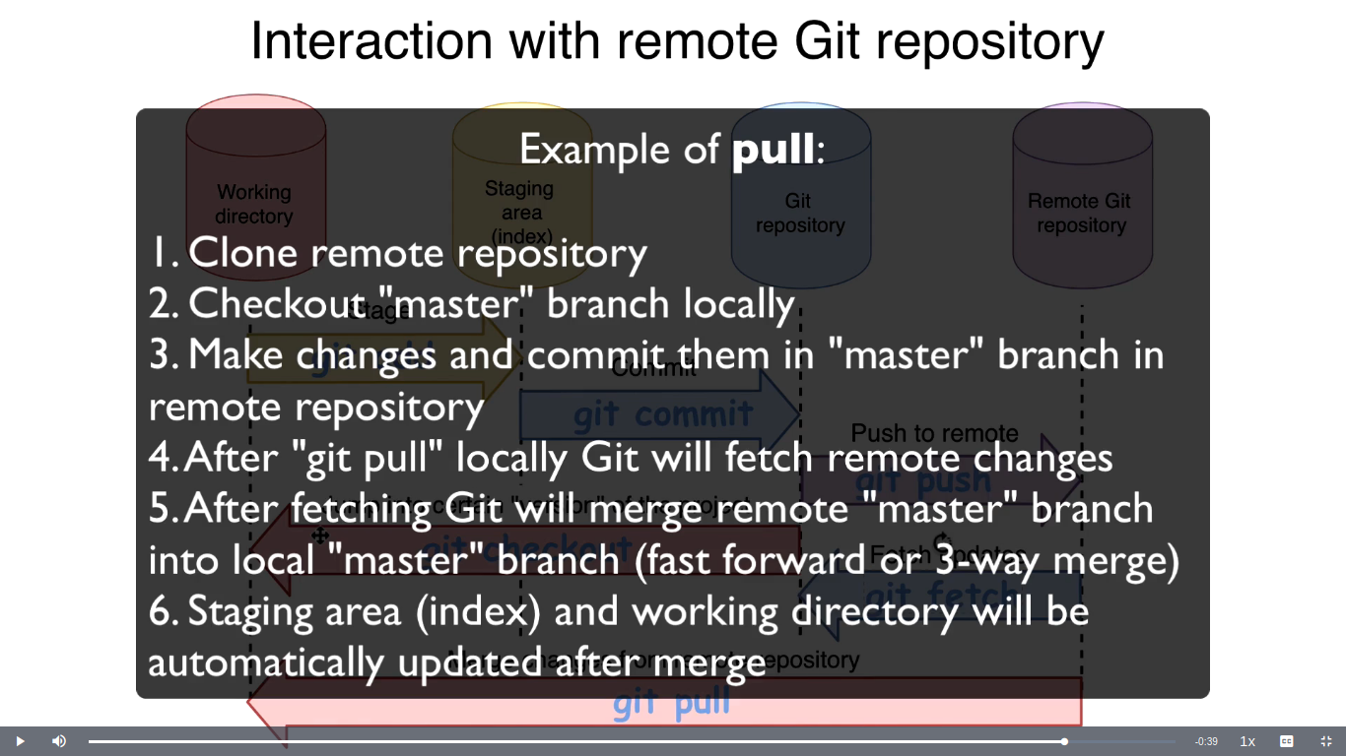
$ git remote
origin

$git remote -v

By default, after cloning, Git will not create corresponding local branches for all remote branches except default remote branch.

$ git branch -a
-lists all local and remote branches

$ git branch -r
-list without remote

Tracking branch

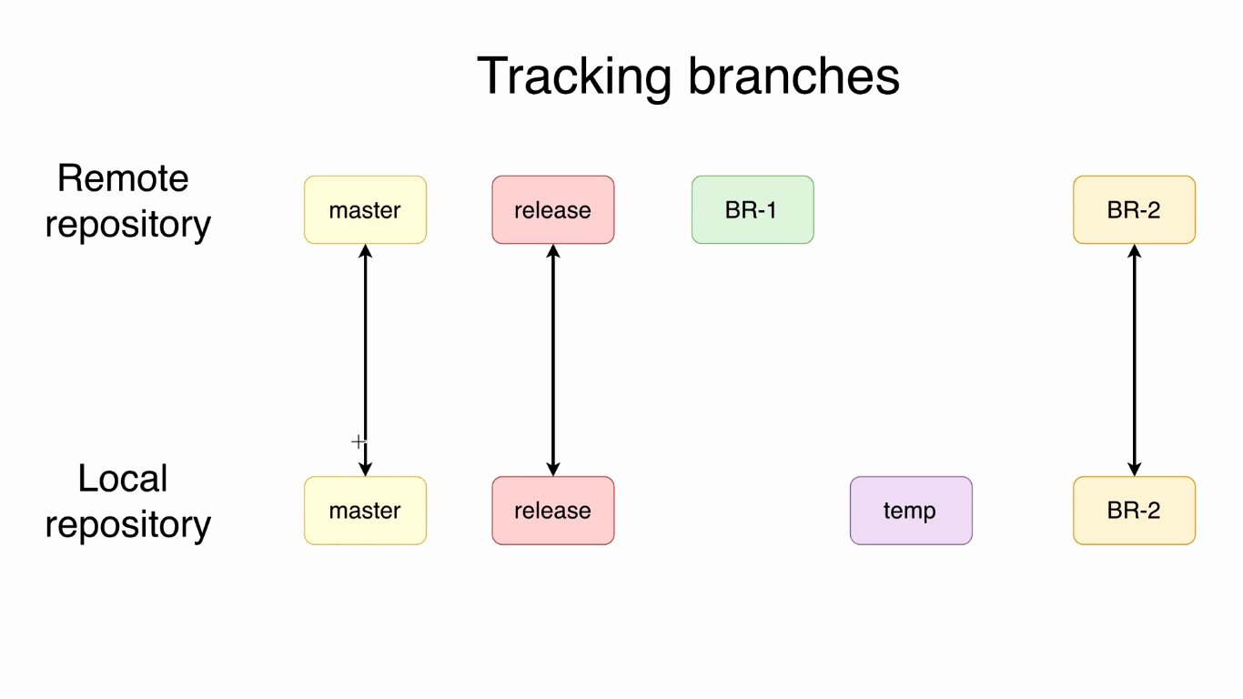
$ git branch -vv

$ git checkout <branch-name>

$ git remote show origin

$ git remote prune origin – Deletes all stale remote-tracking branches under <name>

$ git pull – merges remote branch into current branch

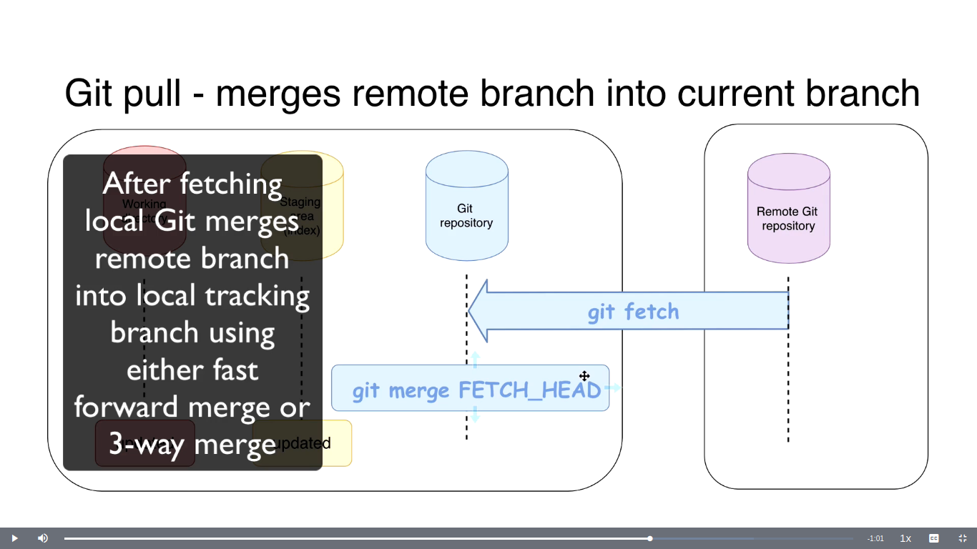

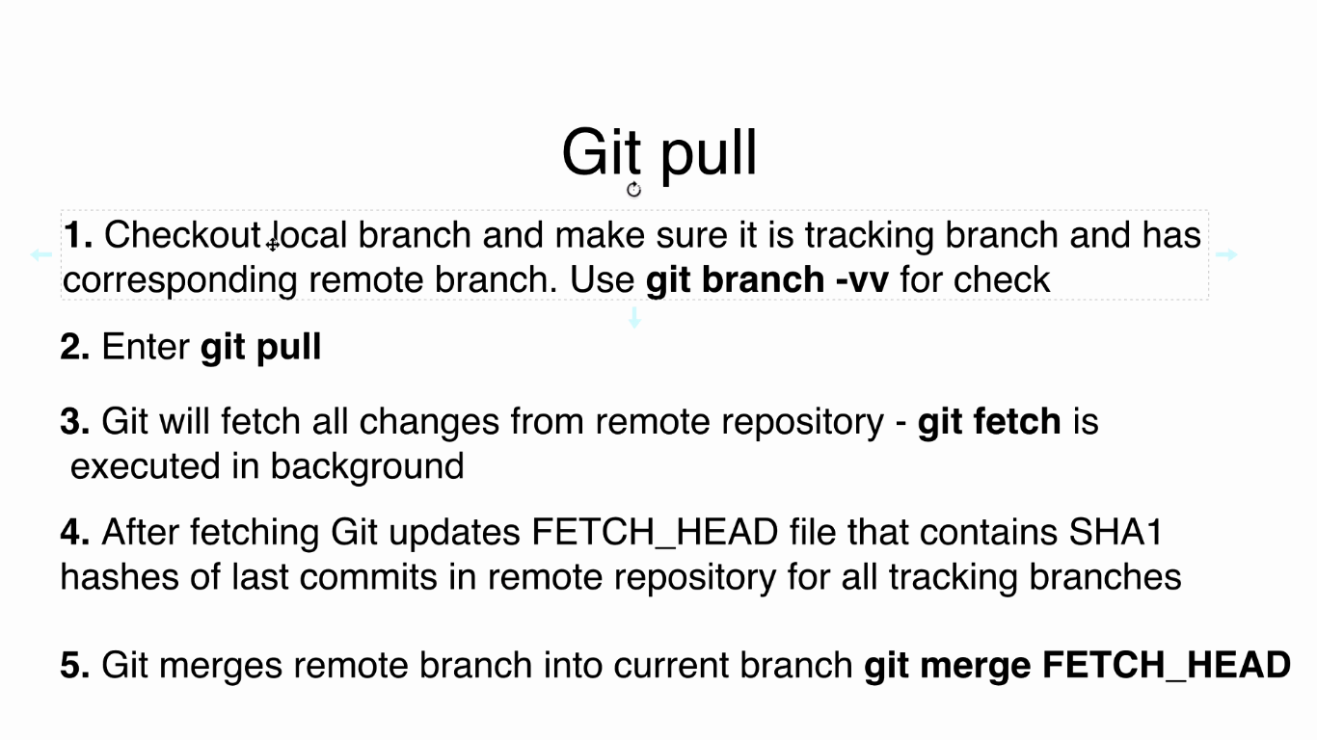

$ git merge FETCH_HEAD

$ cat .git/FETCH_HEAD

